NATIONAL AND STATE TRADE ASSOCIATIONS

Pioneer actively participates in a number of national and state trade associations representing the oil and gas industry. These associations allow the Company to join others in the industry and advance a common agenda on legislative and regulatory matters. These associations allow the Company to join others in the industry to advance a common agenda on legislative and regulatory matters. These groups may use a portion of the contributions for political activities. Their efforts in this regard are subject to reporting requirements under federal and state laws. The Company receives information from trade associations regarding the portion of our dues or contributions that are used for lobbying or political purposes. Below is a list of trade and business associations to which the Company contributed in 2019 that have advised us that a portion of our dues and other payments were used for lobbying or political expenditures and such amounts that were used for lobbying expenses or political expenditures are reported below:

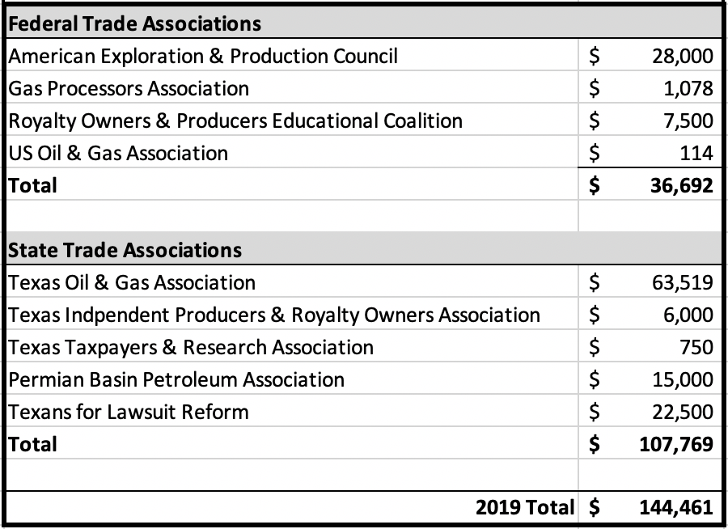

Reflects only the portion of membership dues and other payments to trade associations that were non-deductible under Section 162 (e) (1) of the Internal Revenue Code.

Note: A contribution to Independent Petroleum Association of America (IPAA) made in 2018 also directed $31,500 to 2019 federal lobbying expenses or political expenditures.

