This Quick Reference Guide and associated import template should only be leveraged for OpenTicket submissions in OpenInvoice related to a Parsley Energy dispute where direction was provided in the dispute to submit the transaction to Pioneer Natural Resources.
- Log in to OpenInvoice. https://www.openinvoice.com/docp/public/OILogin.xhtml

Note: For access, please contact your internal OpenInvoice administrator or openinvoicesupport@oildex.com.
- If taken to the Desktop Version, move cursor over the Ticket icon and choose Search.
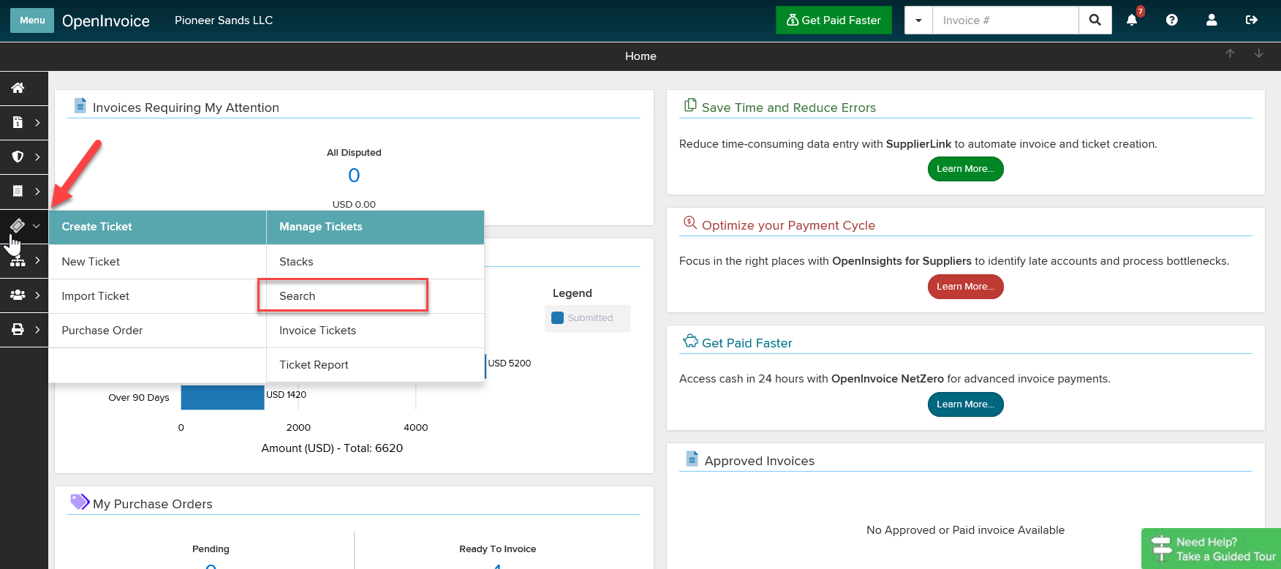

- From Search page, choose Disputed as Status. Enter Parsley Energy as Buyer Name and Export Detailed Report.

Important Note: Any additional filters (i.e. date) or reports (i.e. Summary) will not format correctly with the template. Cancel any disputed transactions that should not be billed prior to requesting the report.
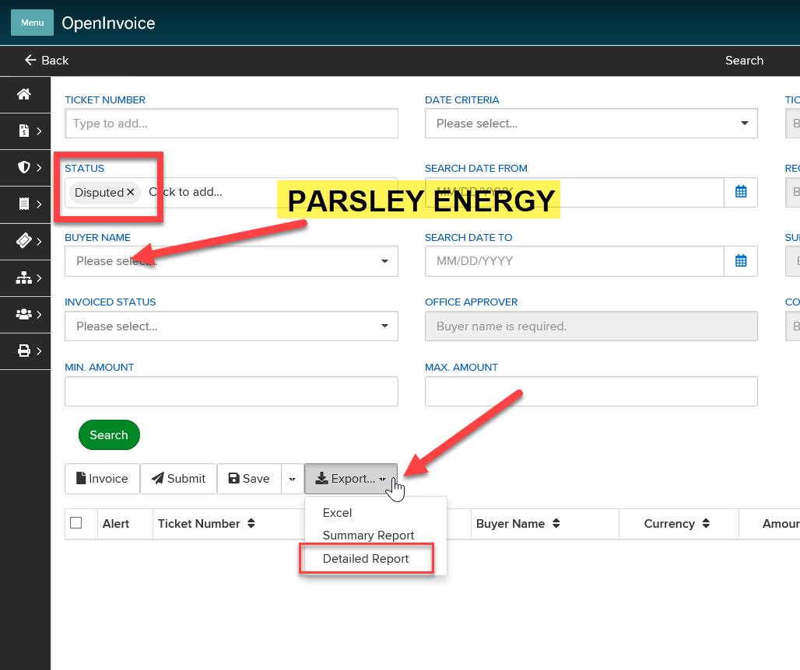

- You will find the completed report by rolling over the Printer icon and under Completed Reports
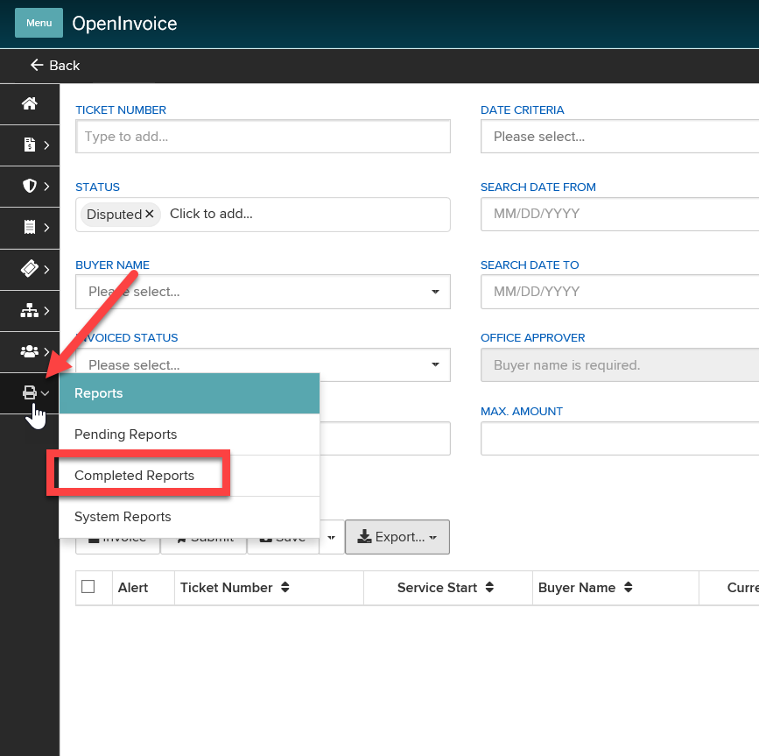

- Once report is complete, open the Ticket Search Detailed Report AND the General Ticket Import_Pioneer file in Excel workbook.
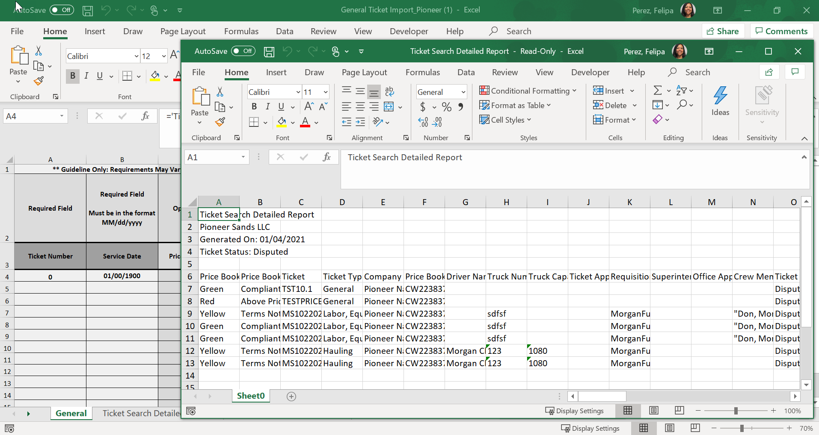

- Copy/Paste full sheet of the Ticket Search Detailed Report into the “Ticket Search Detailed Report” tab on the General Ticket Import_Pioneer excel workbook. Once the data has been transferred, you may close the original Ticket Search Detailed Report.

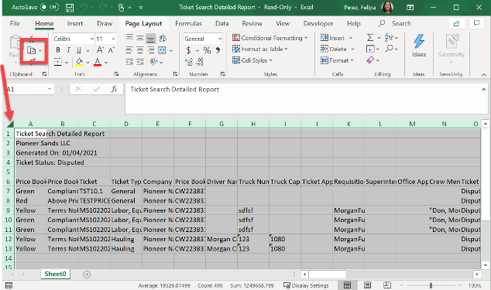

Excel tip: Click the Select All button (above arrow indicates Select All button)
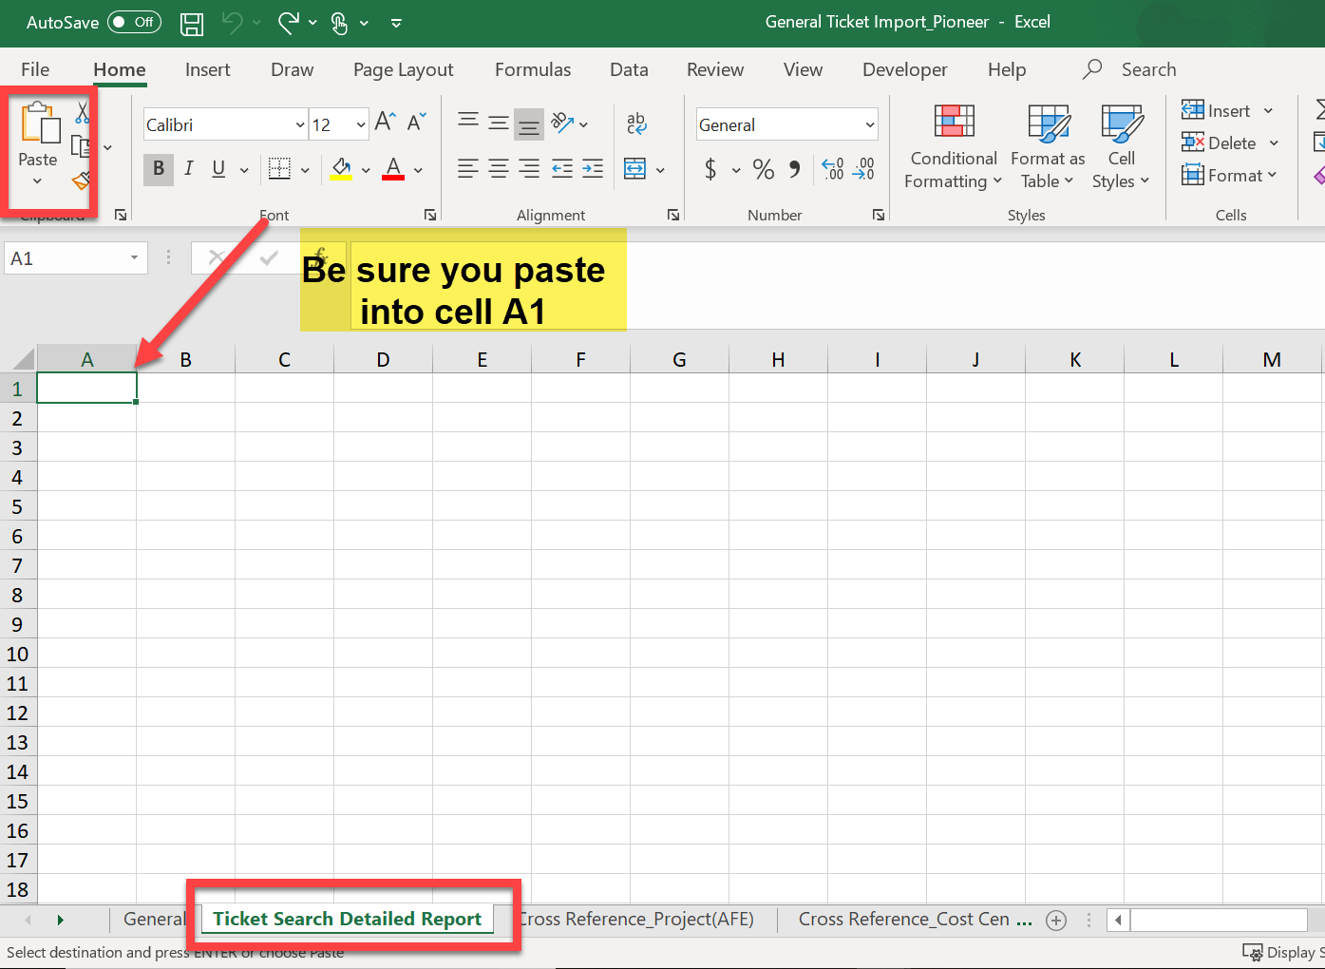

- On “General” tab, (a) select row 4 column A-T and (b) drag right bottom corner down until you see 0 results (c) go back to last real result.

(a)
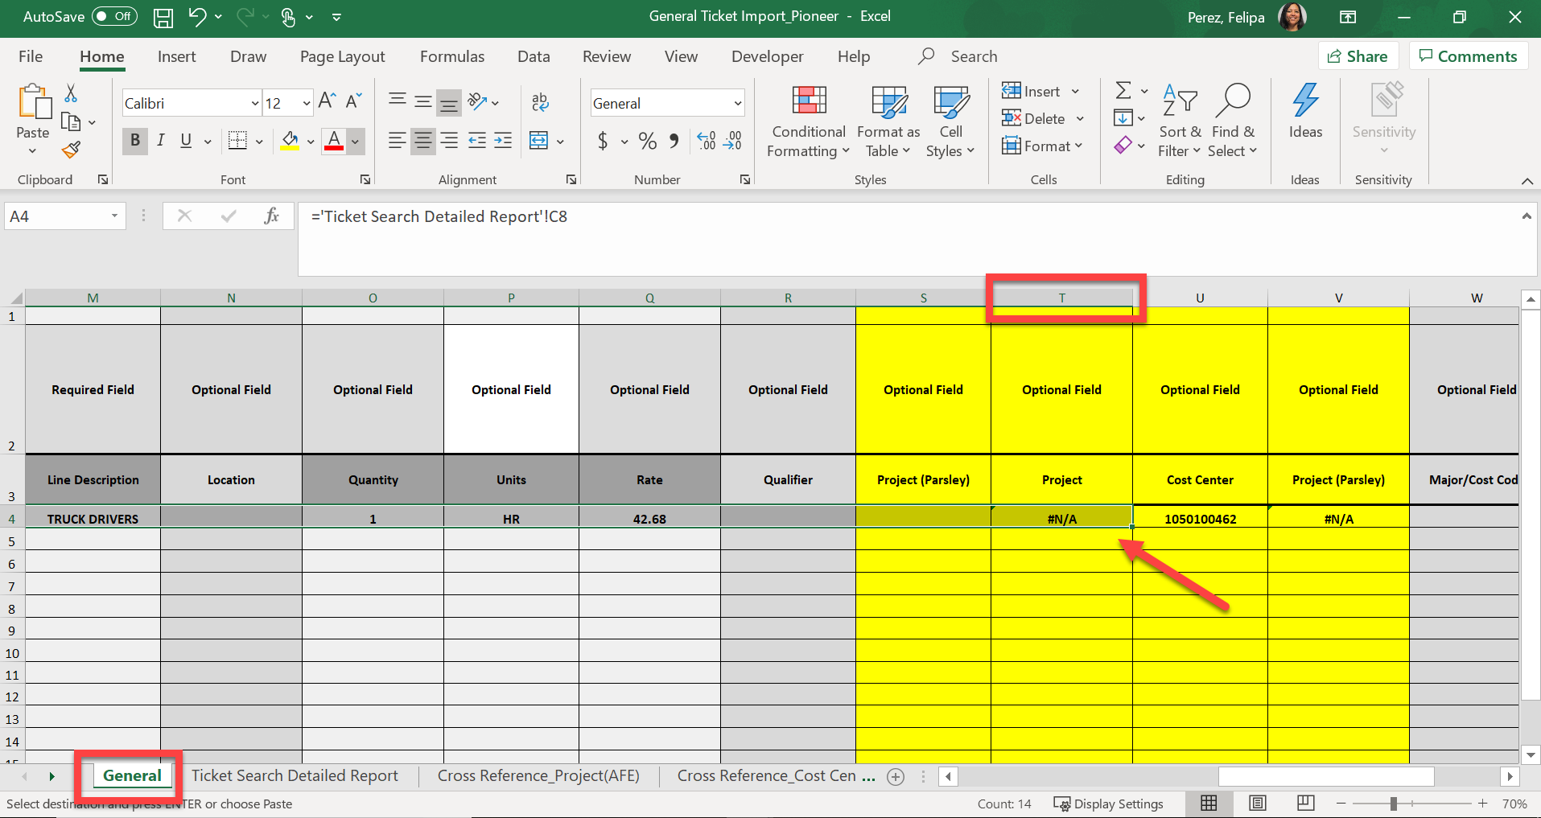

(b)
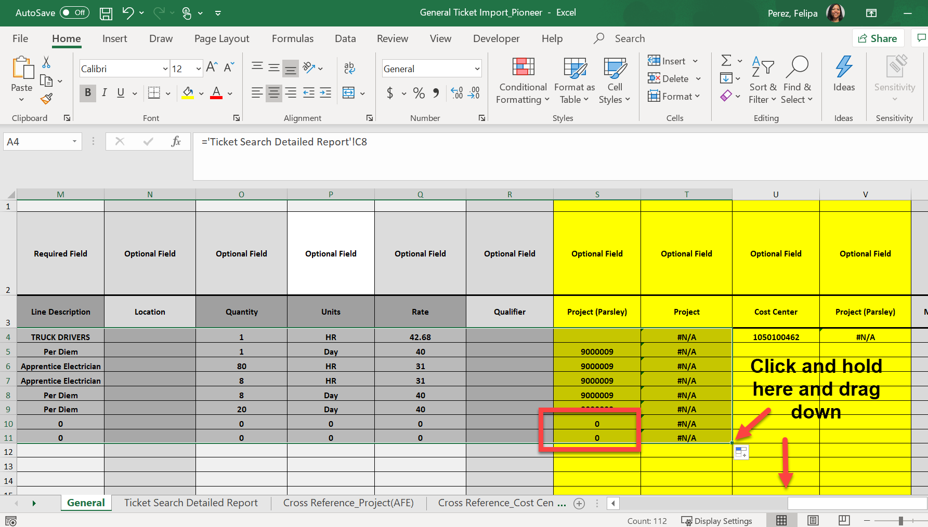

(c)
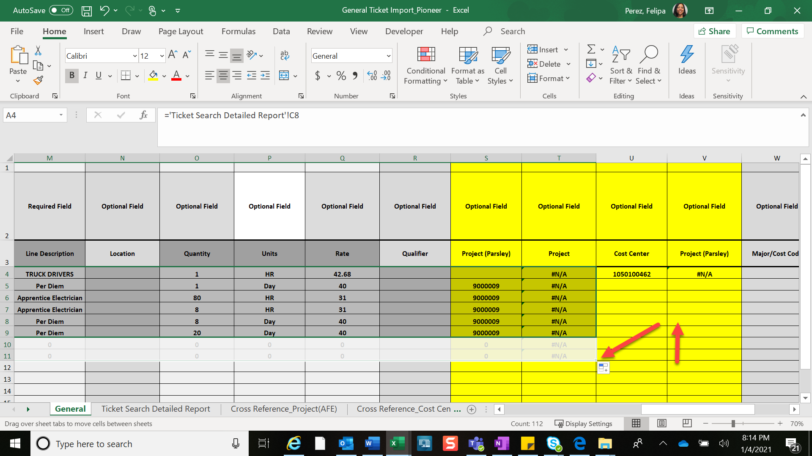

- Copy and paste “values” (123) for entire “General” data sheet

Excel Tip: How to Copy Values in Excel:
- Select all
- Copy
- Click drop down under Paste
- Choose Paste Values (icon with 123)
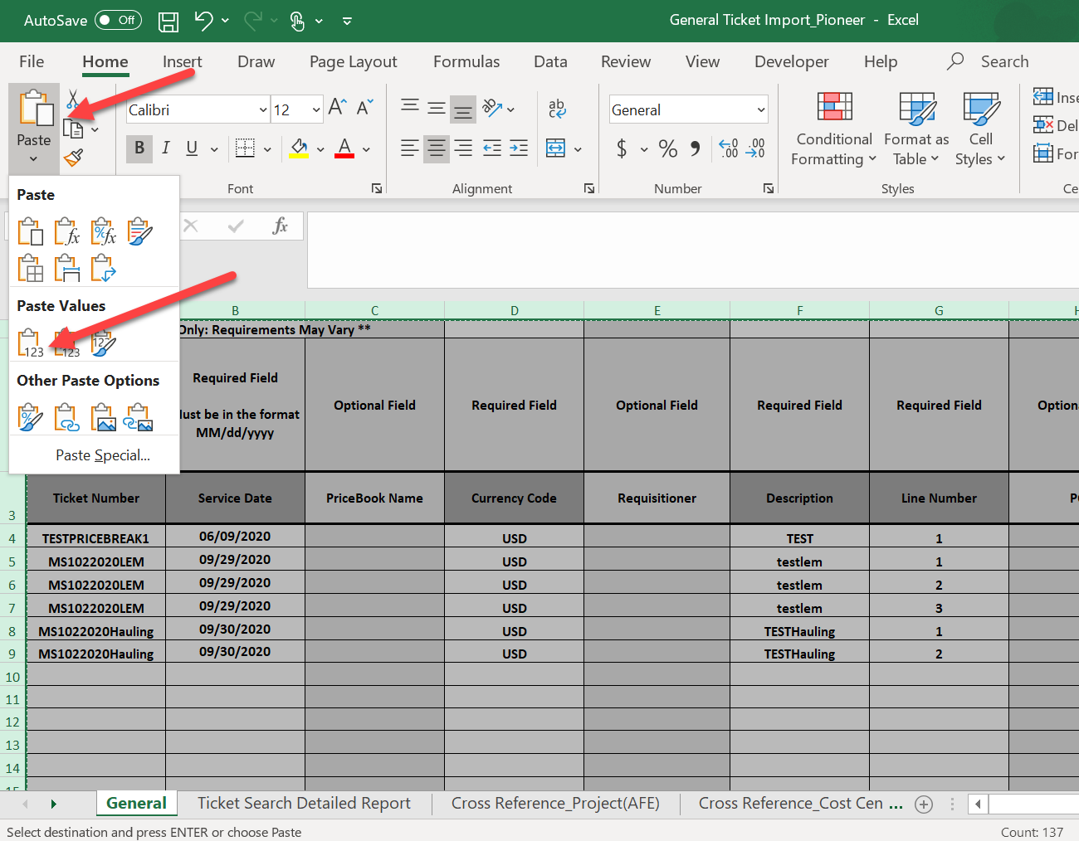

- Delete column S “Project (Parsley)” then column U “Cost Center (Parsley)”.

Excel Tip: How to select entire column.
Position cursor above column until turns into black down arrow then left click. Right click and choose Delete.
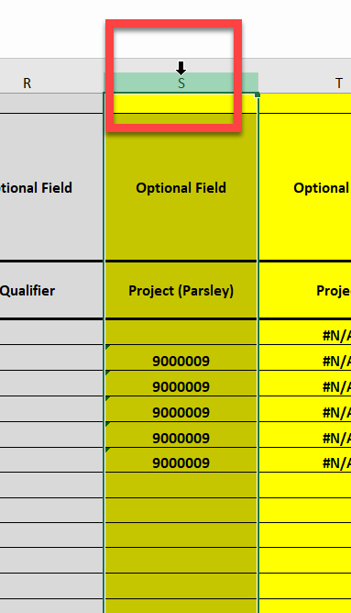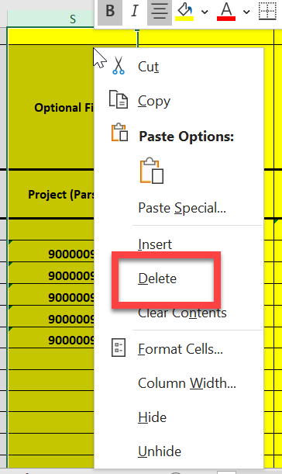

- Select column S Project and T Cost Center to find and replace all “N/A” values with a null value before saving the file.

Excel Tip: Use the Find & Select feature to Find all cells with #N/A and replace with an empty cell.

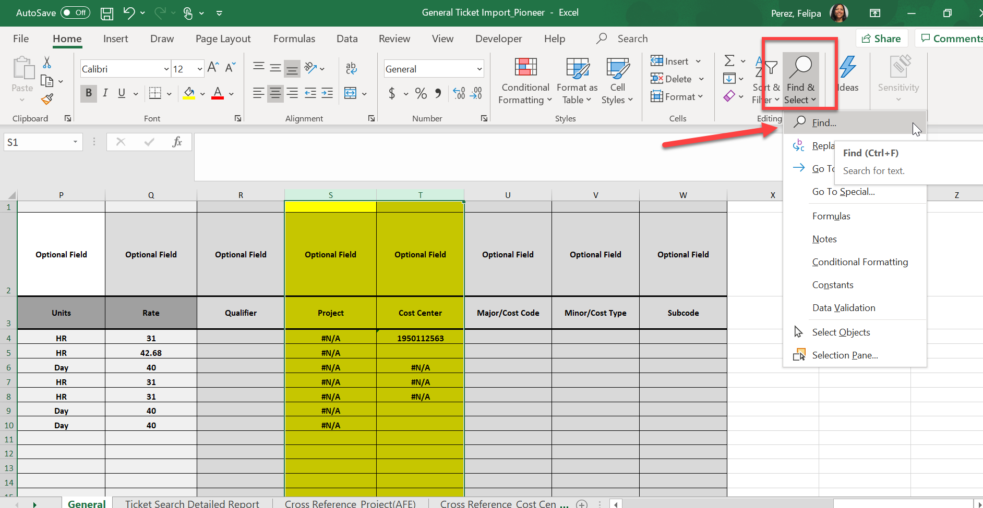

Enter #N/A in Find what field then Click on Find ALL 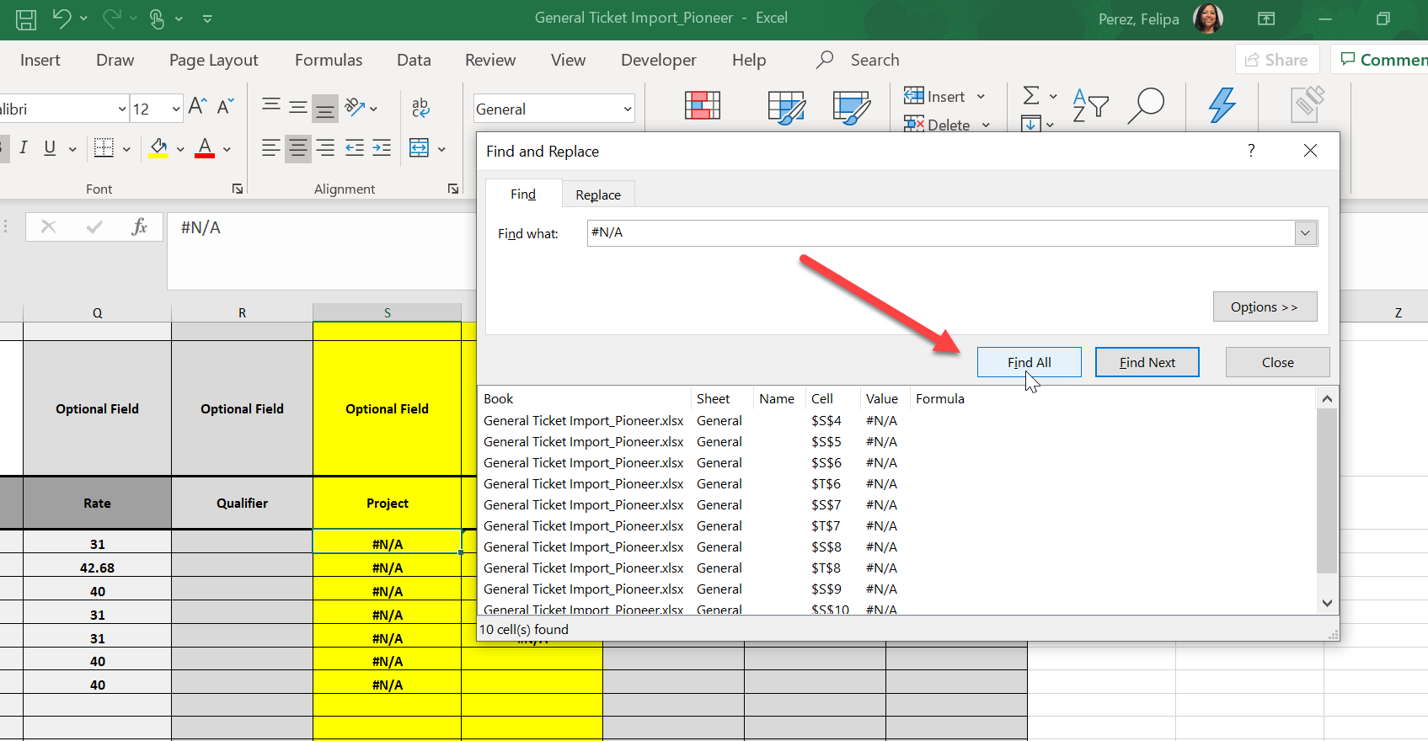

Choose the Replace Tab and leave the Replace with: field blank. Select Replace All
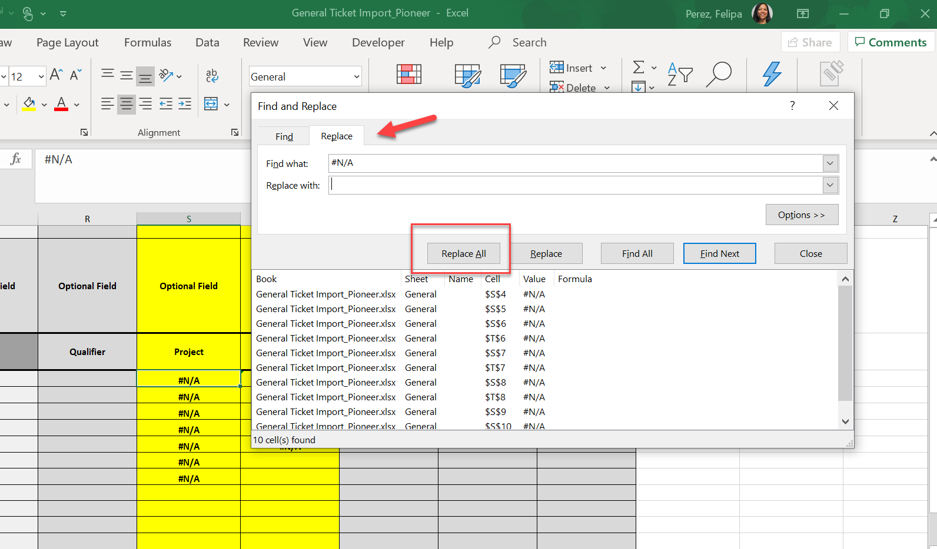

Important Note: A project and/or cost center value is optional to create but required for submission. SupplierHelp@pxd.com can assist if the ticket does not meet our submission requirements.

- Delete sheets Ticket Search Detailed Report, Cross Reference_Project, and Cross Reference_Cost Center. Leave only the General sheet. Save document.

Excel tip: How to delete a sheet.

Scroll cursor over the sheet name tab and right click. Choose Delete.

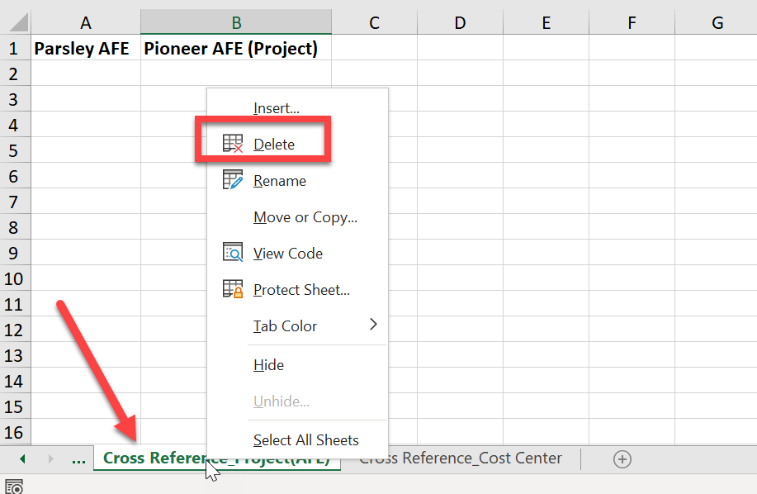

- Drag and drop the saved General Ticket Import_Pioneer for import by selecting Import Ticket from the OpenTicket menu icon and selecting Pioneer Natural Resources as supplier site name and company.

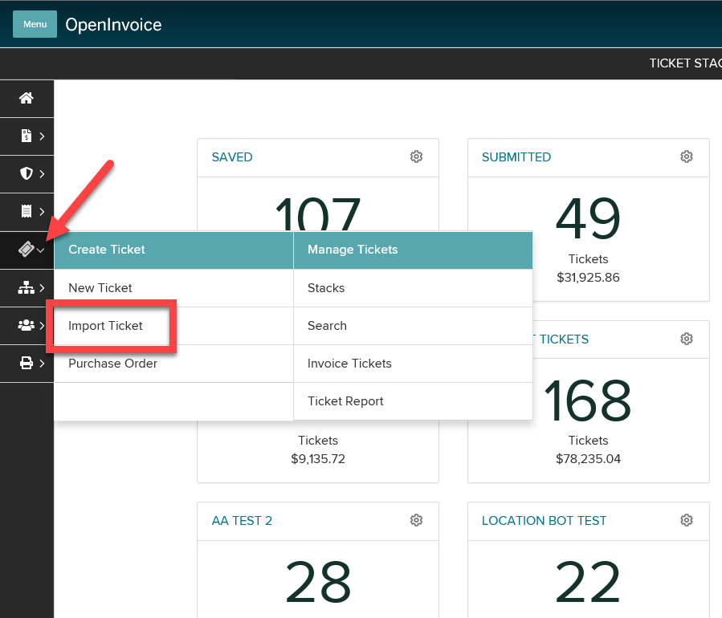

Drag and drop file into the drop box and click Import Tickets.

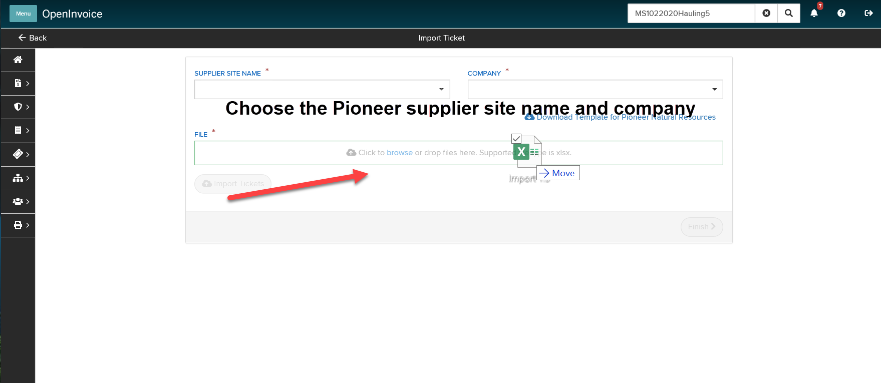

Click Finish and a list of imported tickets will appear.
Important Note: Importing tickets will place the tickets in saved status. The ticket will need to be submitted for further processing.

- To submit all tickets at one time, click the box in the upper left corner. This will check all boxes. Click Submit.

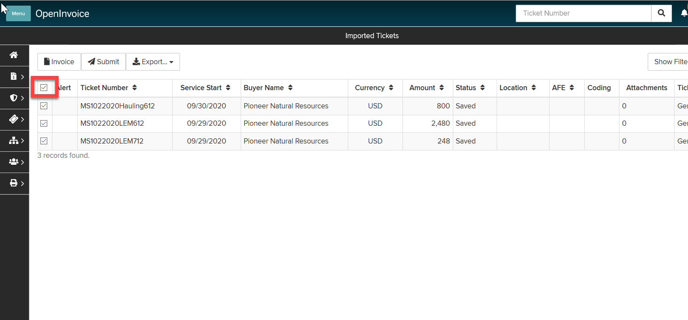

- Include a submission comment “Per Parsley Energy dispute, submitting to Pioneer Natural Resources”. If needed, edits can be completed in OpenInvoice prior to or after submission.

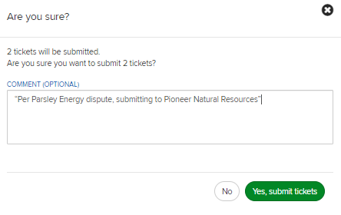

Important Note: A requisitioner OR location value will be required for future submissions not related to a Parsley dispute. Please review all submission requirements and guidelines at https://pxd.com/operations-innovation/suppliers/current-suppliers.

